What benefits will my child get from Forest Schools?
Forest Schools supports the holistic development of the child:
- Health and Physical Exercise – Being active in an outdoor natural environment;
- Increased emotional wellbeing – This is proven by research;
- Social Development – Communicating and negotiating with peers and adults to solve problems and share experiences;
- Skills development – Developing fine and gross motor skills and coordination for real purposes;
- Gaining knowledge and understanding – Multi-sensory, real life learning;
- Individualised learning – Careful observation allows adults to tailor support to children’s own interests and stage of development;
- Curriculum links – Forest Schools supports many areas of the Early Years Foundation Stage framework, National Curriculum and Every Child Matters agenda.

Health and Safety
The health and safety of all participants is central to everything done within a Forest Schools programme. Forest School leaders are fully trained in risk assessment and emergency outdoor first aid.

Every Forest School will have:
- A Health and Safety Policy;
- A seasonally, and daily risk assessed site;
- Risk assessments for specific activities;
- Trained adult helpers;
- First aid and emergency equipment.

Some of the activities that your child might participate in are ‘higher risk’ activities, such as campfire cooking or tool use. However, these activities are not available to the children until certain behaviours and boundaries are established. Children are encouraged and supported in recognising and managing risks for themselves through real life situations and experiences.

For further information, please speak to Nicky ‘Nightingale’ Powell
(Forest School Leader)
Forest Schools
at St George’s C of E Primary School
A Guide For Parents
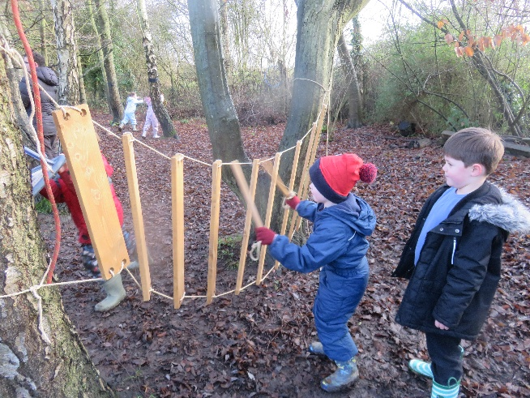
“This is the best kind of classroom,
It’s a journey through time and space,
From the smallest seed to the largest tree,
A forest and a learning place.

This is the best kind of classroom,
Where the seasons don’t happen in books,
Where the learning is watching and thinking and talking,
And everyone notices, everyone looks.”
From ‘The Best Kind of Classroom’ by Ian Macmillan
What is Forest Schools?
Forest Schools has developed from the Scandinavian education system and is about children and young people building self-esteem and independence through exploring and experiencing the natural world. Forest Schools is a long-term programme delivered by qualified and trained practitioners within a natural environment. Each Forest School programme is tailored to meet the needs of individuals and is continuously developed as the learners grow in confidence, skills and understanding.
The ethos of Forest Schools allows learners the time and space to develop skills, interests and understanding through practical, hands-on experiences. It also allows practitioners to step back and observe the children in order to then encourage and inspire individuals to achieve through careful scaffolding and facilitating.

Where will my child be going?
Our Forest School site at St George’s is within the school grounds and is located at the back of the school field, running the entire width of the grounds. It is home to the peace garden, wildflower garden, log circle, main forest area, mud pit and kitchen, and pond area.
Our site is full of natural features, including sticks, logs, leaves and seeds, some of which have been imported in from other sites. Our site is a safe area which has been thoroughly risk assessed and managed appropriately by trained practitioners.
“Forest School is an inspirational process that offers children and young people opportunities to achieve, develop confidence and self-esteem, through hands on learning experiences in a local woodland environment”. National definition: by Forest School (England) Network

What will my child be doing?
Your child will get dressed for Forest Schools in the classroom and put on their wellington boots. They will then take a walk down to the log circle where the session will begin each session with an introduction.
Sometimes we will talk about how we feel, do a nature spot, suggest what we would like to do during the session or listen carefully to a ‘Tool Talk’ if it is relevant to the session.
Forest Schools will run all year round, regardless of weather. It is therefore imperative that your child comes dressed appropriately to the time of year, with layered clothing, waterproofs and welly boots. Regardless of the time of year, we would always suggest that your child has long sleeves and trousers as we are home to various plants, including stinging nettles and thorns, which are encouraged to grow wildly, and ticks are more prevalent during warmer months.
When weather conditions are too dangerous, e.g. in high winds, we will find an alternative place to enjoy our session, usually in the Dragon’s Cabin, away from trees and the potential of falling branches.
The child-led ethos of Forest Schools means that the children can choose what they would like to participate in, carefully supported and encouraged by trained adults. Possible activities may include:
- Hunting for minibeasts of pond dipping;
- Natural crafts – making necklaces from Elder, collages of natural materials, tree cookies, and much more!
- Mud sculptures;
- Shelter building and knot tying;
- Tree climbing;
- Using tools for a purpose – such as peeling bark from sticks with a butter knife or potato peeler (known as whittling);
- Fire lighting and cooking on a camp fire.
Sessions are planned around the individual and group needs, and built upon each week. All Forest School leaders are qualified through nationally recognised and accredited training, therefore ensuring Forest Schools is a high-quality learning experience. The earlier sessions will concentrate on safety, establishing boundaries and routines. As the children develop in confidence and familiarity with the environment, the sessions focus on the development and consolidation of skills and understanding.

