22 January 2020

Dear Parents/Carers

There has been a case of head lice recently identified in Class 1.

We would like to work together to get rid of head lice in our school, so we suggest that you check your child’s hair as soon as possible.

We also suggest that you continue checking on a weekly basis. This will help to prevent head lice returning repeatedly.

If you want to find out more about headlice, go to www.headlice.co.uk.

Please also remember that our school uniform policy states that all long hair should be always tied back when in school.

Thank you for your co-operation.

Yours sincerely
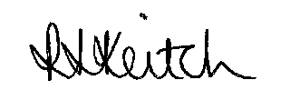

Mrs R Keitch
Headteacher

