
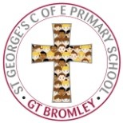
Subject at a Glance Summer 2022: ART

When our pupils leave St George’s at the end of Year Six, our aim for them is….  What does an Artist look like?  Artistic pupils can express their individual creativity, working both individually collaboratively.  Art engages, inspires and challenges pupils – equipping them with the knowledge and skills to experiment and invent.  Through Art, pupils develop curiosity and observe the world more carefully- connecting with their own culture as well as that of the wider world.  Art allows pupils to express their feelings, ideas- both as a means of self-expression and to communicate with others.  Through Art, pupils develop language skills, social skills, decision making and risk taking. | What does it mean to be an Artist at St George’s?  At St George’s Primary School, we want our children to love art, craft and design!  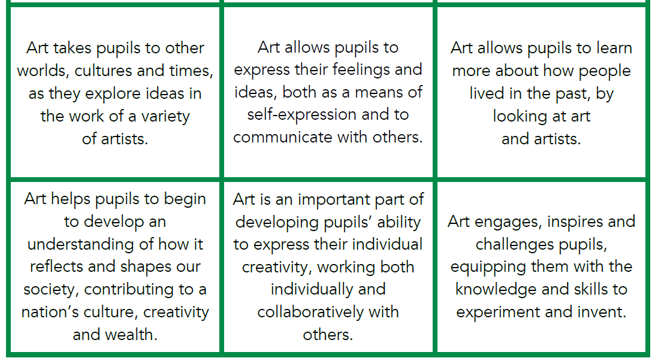  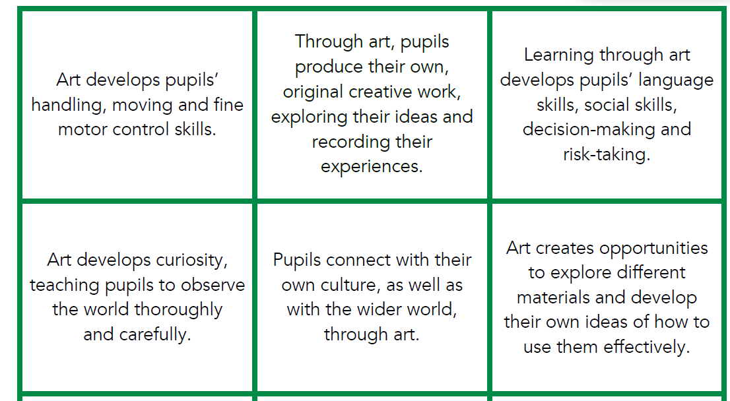
Strengths in Current Provision  (Based on audit Spring 2022) | Practice | Impact on children’s learning  (This is good because….)
Strengths in Current Provision  (Based on audit Spring 2022) | - Long and Medium Term Planning sets out clear Knowledge and skills progression (Dimensions Curriculum) enabling carefully sequenced teaching  - Teachers have explored and developed artist links to all of their Dimensions units in cycle A. | - Pupils build on their knowledge and skills as they move through the phases, knowing and remembering more.  - Curriculum has been expanded and developed to suit our children at St George’s. This will ensure children will have exposure to a wide variety of artists and mediums.
Priorities for development  (Maximum of three, at least one of which should be an action for the subject leader rather than all staff). | Priority – Action required | Intended impact on children’s learning  (This is needed because….)
 | - Ensure that link artists are included and developed throughout Cycle B –Prior to September 2022. – Each class to complete own CYCLE B art link. Rebecca (Art subject lead to fill in any gaps to support staff).  - Audit resources – ensure that the artists and tasks linked to Cycle A and B have appropriate resources in stock for school. (Rebecca- As Art Subject Lead to complete).  - Ensure children have opportunities to create Art throughout school – All staff and children to have a clearer picture of what being an Artist at St George’s looks like. | - This will allow better exploration and exposure to a variety of art types and artists in each class.  - Staff and children will have access and guaranteed availability to resources when they are needed.  - Each member of staff to have a clear vision of what being an Artist at St George’s looks like. Making sure that children are exposed to and explore both different mediums and artists. Not just illustrating or drawing within other subjects.

