Spring Term (1) CLASS LETTER

Dear Parents and Carers

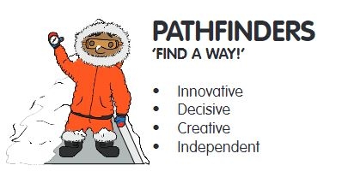
Happy New Year! We hope that you all enjoyed your Christmas breaks and we are looking forward to welcoming you all back to another fun filled half term. This letter contains all the information you need to know about your child’s learning for the coming half term, including how you can support your child’s learning at home.

DIMENSIONS LEARNING MEANS THE WORLD

This half term we will be starting by studying our new Dimensions unit- The Dancing Spy which concentrates on the life of Josephine Baker. Dancing Spy is a history-based theme, with a focus on the four competencies of courage, commitment, creativity and community, integrating the subjects of PSHE, drama, English, dance and geography. The story of Josephine Baker, a black American entertainer who fought hard against racism and segregation, is both inspiring and challenging. Following on from this our next unit will be “Land Ahoy!”. This is a thematic unit, with a subject focus on science and geography. The science element is based around sound, speed and motion and we begin by exploring how things move, linking with a pirate’s journey around the continents and oceans. Threaded through is the theme of behaving responsibly, with consideration for others.
MATHS

What we’re studying  Over this half term, we will be continuing to explore the place value of numbers developing children’s knowledge and understanding of larger numbers. We will also be developing their knowledge and understanding of multiplication and division we will be using practical resources to help support us with this initially. We will look at the relationship between addition and multiplication using repeated additions to explore multiplications while also learning our 2 and 10 timestable for Year 1 and 2, 3, 5 and 10 for Year 2. We will also move onto looking at division as sharing equally and once again begin exploring this concept through practical resources. | Suggested home activities  To help support your child at home, you could practice counting in 2’s and 10’s. It would be great to practice the pattern in the car, around the house or whenever you have 5 minutes. To help develop your child’s division practice sharing things out fairly. Use apple slices or smarties on plates and make note with your child how things need to be shared out fairly.  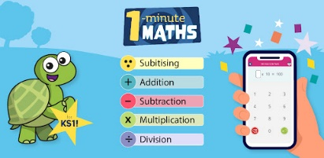  If you have a device and are able to download, there is a free App for a tablet or phone called ‘1-minute maths’ which is made by White Rose Maths.  This has short bursts of questions in categories and brings up a hint like a tens frame to help solve them. You could look at the ‘Multiplication’ or ‘Division’ categories.  .
ENGLISH

What we’re studying  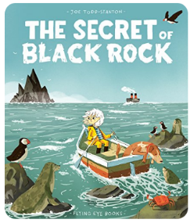  This half term we will be looking at a lovely key text- The Secret of Black Rock by Joe Todd –Stanton. During this unit, we will be exploring quality vocabulary choices, poetry, adjectives used to describe. | Suggested home activities  Why not research some fishing communities, research animals which live in the sea. What adjectives can you use to describe them? There are also some great books which you can share together too:  -The Big Book of the Blue, Yuval Zommer  -Deep in the Ocean, Lucie Brunellière  -Dougal’s Deep-Sea Diary, Simon Bartram  -Shark Lady: The Daring Tale of How Eugenie Clark Dove Into History, Jess Keating and Marta Alvarez Miguens  -Gracie the Lighthouse Cat, Ruth Brown (Andersen Press)  -My Green Day. 10 green things I can do today, Melanie Walsh (Walker)  -10 Things I Can Do to Help My World, Melanie Walsh (Walker)
OTHER SUBJECTS

History- During our Dancing Spy unit, the children will be reflecting on their personal history by reflecting on their homes, family and comparing it to that of Josephine Baker. We will also be looking at racial segregation and racial equality and how Josephine Baker played her part.
Geography- We will be looking back at the continents and oceans around the world.
Science- In our Land Ahoy unit, we will also be exploring how things move and begin by exploring Forces.
Art- In art we will be looking at colour mixing. We will be identifying the primary colours and looking at how to use these to create other colours on the colour wheel.
DT- We will also be creating our own Pirate ships by reflecting on what our Pirate client needs- Watch this space we may need some help with junk model resources.
Music- We will be looking at how music can change from loud to quiet.
PSHE- In our PSHE learning, we will be looking at equality and being fair. We will be discussing how to be kind and how our actions can reflect what we think or feel. We also will be reflecting on rules and expectations and linking them to that of the high seas. We will be looking at taking turns and how to take part in decision making as a team.
HOME LEARNING ARRANGEMENTS
Home Learning-
There will be a slight change to Home learning this half term. We will continue to collect home learning in on Monday’s but will be sending new home learning out on Tuesday. Please make sure children have handed in their home learning on Monday as this gives Mrs Elliott time to mark and send home the next one. We always remind children throughout the day on Monday and we ensure that everyone has new homework on Tuesday regardless of whether they have handed in their folder or not. So please always check book bags just in case your child’s folder was not handed in.

Feedback will be given to children verbally about their homework however it will be stamped by Mrs Elliott to acknowledge homework has been handed in.

Homework will rotate between high frequency words, maths and English tasks allowing the children the opportunity to practice a variety of their skills.

Reading-
Reading is an incredibly important skill to develop and at St George’s we recognise the time and effort that it takes to become a good reader. To help your child’s reading continue to make progress, please read with your child at least 5 times a week. Mrs Pryer will continue to check reading records every Friday.

Reading books-
Reading books will continue to be changed weekly as follows: -
Read Write Inc. book bag books to be changed on Monday
Read Write Inc. Paper books to be changed on Friday
Oxford Owl staged book linked to their RWInc level to be changed on Friday.
Please note-If your child is part of The Literacy and Language group, your child will only have one longer book to take home for reading changed on Monday and reviewed on Friday.

Children should not have more than these books from school in their bags so please encourage your child to return books so that others can enjoy them too.

PE/FOREST SCHOOL

PE will continue to be on Tuesday afternoon with our PE coaches.
Forest school has finished this term for Pathfinders, so instead Pathfinders will have second PE session on Friday please send your child to school in their PE kit today.

SHOW AND TELL
We love sharing the children’s interests and achievements and we think it is important to make time to share these and celebrate them as a class. With this in mind, we have generated a rota for ‘Show and Tell’. Children can bring in toys, certificates, books, or anything that they would like to share on their day. The children’s ‘show and tell’ will be kept in a basket and only allowed to be shared at the designated show and tell time. We would like to ask that children only bring in toys on their show and tell day. Toys are not allowed in school at any other time – this includes cuddly toys. Show and tell will be on MONDAY’s – please see the below rota as well as the message sent out via Seesaw:
09/01/22- Ivy, Byron, Jacob, Blake, Theodore
16/01/22- Eliza, Alexander, Theo, Darcy, Oliver
23/01/22- Jude, Crewe, Bella, Adara, Edith
30/01/22- Harriet, Ella-Rose, Bailey, Konan, Zachary
06/02/22- Toby, Alice, Jack, Oscar, Lucas
13/02/22-Meredel, Isabelle, Lily, Holly
COMMUNICATION

Thank you for all of your support so far this year, we really appreciate it and a huge thank you for all of your kind gifts we really do appreciate but do not expect them. We truly believe that we are all a team. It is very important to us that you are able to communicate and contact us when needed. For quick, day-to-day classroom matters please contact us via Seesaw or at the beginning/end of the day, an adult will also be at the door for drop off and pick up.

For queries, questions or concerns, please make an appointment to meet with us or have a phone call via the school office.

We will respond to your queries as soon as we are able to, but please keep in mind that we may not be able to check or respond to SeeSaw while we are teaching. So if matters are urgent, please contact the school office.

Kind regards
Mrs Elliott and Mrs Pryer

