Spring Term (2) CLASS LETTER

Dear Parents and Carers

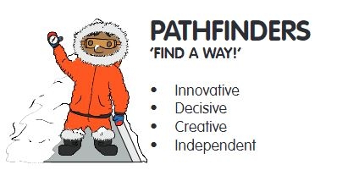
We hope that you all enjoyed your half term break and we are looking forward to welcoming you all back to another fun filled half term. This letter contains all the information you need to know about your child’s learning for the coming half term, including how you can support your child’s learning at home.

DIMENSIONS LEARNING MEANS THE WORLD

This half term we will be completing our unit “Land Ahoy!”. This is a thematic unit, with a subject focus on science and geography. The science element is based around sound, speed and motion and we begin by exploring how things move, linking with a pirate’s journey around the continents and oceans. Threaded through is the theme of behaving responsibly, with consideration for others. As part of this unit we will be exploring coastal areas and features so watch this space for an exciting opportunity to explore this as a class. Our next unit is called ‘Zero to Hero’ this is a thematic unit about heroes and heroines, both past and present, who have overcome major challenges in life and become inspirational gurus. There is a key subject focus on history within this unit as well as personal reflection on people who inspire us and how we can reach our own goals.
MATHS

What we’re studying  Our maths curriculum is starting to get more challenging and the children will be accessing lots of exciting new content;  Year 1 will be continuing to explore the place value of numbers to 50. We will be developing our understanding of what numbers are made of, how we can read, write, compose and compare them. Following on from this Year 1 will also look at measuring length and height. We will be using non-standard units such as ‘cubes’ to measure and compare.  Year 2 will be concentrating on measuring this half term – we begin with a focus on money. At will be challenging the children with not only making amounts of money with mixed coin but also giving correct change. We will then move onto measuring length and height in standard units of measurements. We will be using rulers, and identifying cm and m in our learning. | Suggested home activities  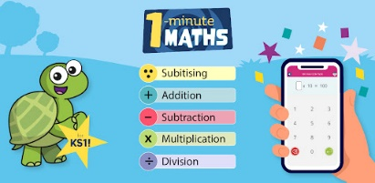  If you have a device and are able to download, there is a free App for a tablet or phone called ‘1-minute maths’ which is made by White Rose Maths.  This has short bursts of questions in categories and brings up a hint like a tens frame to help solve them. You could look at the ‘money’ or ‘length’ unit this half term.
ENGLISH

What we’re studying  This half term we will be looking at a lovely text called ‘Between Tick and Tock’. This is about a girl who notices the things that everyone else is too busy to see. She decides it’s time to pause the clock and lend a helping hand as she carries out little acts of kindness and breathes colour, life and happiness back into the city.  We will be building on our understanding of sentence structure and looking at how we can improve our sentences using adjectives. We will also continue to look at punctuation and writing in role. We will then look at acts of kindness and how we can write persuasively. | Suggested home activities  To help support your child at home, why not try creating extended sentences using describing words and conjunctions (and, but, because.) You could write about what you can see outside as we will now start seeing blossom on the trees and flowers sprouting as Spring returns!  Please continue to practice your spelling words. These can be found in your child’s reading folder, you will find a list of high frequency words and common exception words.
OTHER SUBJECTS

Geography- We will be looking back at the continents and oceans around the world. As well as identifying features of coastal areas.
Science- In our Land Ahoy unit, we will also be exploring how things move and begin by exploring Forces.
Art- In art we will be looking at colour mixing. We will be identifying the primary colours and looking at how to use these to create other colours on the colour wheel. We will be extending this learning to look at Kandinsky’s circles.
DT- We will also be creating our own Pirate ships by reflecting on what our Pirate client needs- Watch this space we may need some help with junk model resources.
PSHE- In our PSHE learning, we will be looking at equality and being fair. We will be discussing how to be kind and how our actions can reflect what we think or feel. We also will be reflecting on rules and expectations and linking them to that of the high seas. We will be looking at taking turns and how to take part in decision making as a team. In our learning we will be connecting thinking and looking at Global Dimensions to help pupils develop a wider perspective and understand the links between their own lives and those of people around the globe, as well as understanding their own place in the worldwide community.
HOME LEARNING ARRANGEMENTS
Home Learning-
We will continue to collect home learning in on Monday’s but will be sending new home learning out on Tuesday. Please make sure children have handed in their home learning on Monday as this gives Mrs Elliott time to mark and send home the next one. We always remind children throughout the day on Monday and we ensure that everyone has new homework on Tuesday regardless of whether they have handed in their folder or not. So please always check book bags just in case your child’s folder was not handed in.

Feedback will be given to children verbally about their homework however it will be stamped by Mrs Elliott to acknowledge homework has been handed in. Homework will rotate between high frequency words, maths and English tasks allowing the children the opportunity to practice a variety of their skills.

Reading-
Reading is an incredibly important skill to develop and at St George’s we recognise the time and effort that it takes to become a good reader. To help your child’s reading continue to make progress, please read with your child at least 5 times a week. Mrs Pryer will continue to check reading records every Friday.

Reading books-
Reading books will continue to be changed weekly as follows: -
Read Write Inc. book bag books to be changed on Monday
Read Write Inc. Paper books to be changed on Friday
Oxford Owl staged book linked to their RWInc level to be changed on Friday.
Please note-If your child is part of The Literacy and Language group, your child will only have one longer book to take home for reading changed on Monday and reviewed on Friday.
Children should not have more than these books from school in their bags so please encourage your child to return books so that others can enjoy them too.
Beyond Read Write Inc.-
The children are working hard on their reading and are all making great progress on it. We have several children who have now completed the RWInc programme and are working within our Language and Literacy group to develop their comprehension skills. Please can we reiterate the importance of continuing to read with your child even at this stage in their learning. It really does make a difference.

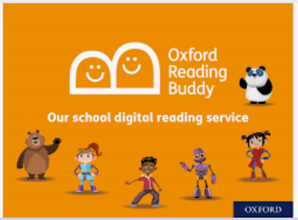
Children within this group have been allocated a log-in on Oxford Reading Buddies. The children were sent home with their log in’s before half term. This is a great platform for offering the children the chance to develop their skills and interact with books in a personalised, modern and child friendly way. We have practiced in school and the children loved engaging with it.
https://www.oxfordreadingbuddy.com/uk
PE/FOREST SCHOOL

PE will continue to be on Tuesday afternoon with our PE coaches.
Pathfinders will continue to have their second PE session on Friday please send your child to school in their PE kit today.
SHOW AND TELL
We love sharing the children’s interests and achievements and we think it is important to make time to share these and celebrate them as a class. With this in mind, we have generated a rota for ‘Show and Tell’. Children can bring in toys, certificates, books, or anything that they would like to share on their day. The children’s ‘show and tell’ will be kept in a basket and only allowed to be shared at the designated show and tell time. We would like to ask that children only bring in toys on their show and tell day. Toys are not allowed in school at any other time – this includes cuddly toys. Show and tell will be on MONDAY’s – please see the below rota as well as the message sent out via Seesaw:
20/02/23- Ivy, Byron, Jacob, Blake, Theodore
27/02/23- Eliza, Alexander, Theo, Darcy, Oliver
06/03/23- Jude, Crewe, Bella, Adara, Edith
13/03/23- Harriet, Ella-Rose, Bailey, Konan, Zachary
20/03/23- Toby, Alice, Jack, Oscar, Lucas
27/03/23-Meredel, Isabelle, Lily, Holly, Fifi
COMMUNICATION

Thank you for all of your support so far this year, we really appreciate it and a huge thank you for all of your kind gifts we really do appreciate but do not expect them. We truly believe that we are all a team. It is very important to us that you are able to communicate and contact us when needed. For quick, day-to-day classroom matters please contact us via Seesaw or at the beginning/end of the day, an adult will also be at the door for drop off and pick up.

For queries, questions or concerns, please make an appointment to meet with us or have a phone call via the school office.

We will respond to your queries as soon as we are able to, but please keep in mind that we may not be able to check or respond to SeeSaw while we are teaching. So if matters are urgent, please contact the school office.

Kind regards
Mrs Elliott and Mrs Pryer

