SPRING 2 CLASS LETTER

Dear Parents and Carers,

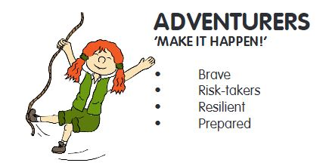
Welcome to this half-term’s class letter. This letter contains all the information you need to know about your child’s learning for the coming half term, including how you can support your child’s learning at home.

DIMENSIONS - LEARNING MEANS THE WORLD
Our current topic this term is called ‘Viking Warrior.’ “Viking Warrior” is a competency-based thematic unit with a history focus, telling the legendary story of Ragnar Lothbrok. He is a Viking “sea lord” who, according to his very famous saga, invaded the ancient Kingdom of Frankia and then the British Isles over 1000 years ago. He is known for wearing “hairy trousers”, which protected him on his adventures.

The children will be learning these key objectives through this unit of learning…

To know and be able to retell the life story of Ragnar Lothbrok
To know the chronology of invaders and settlers in Britain To understand that Viking sagas were often written down many years after the events had possibly happened and, therefore, may contain more fiction than fact
To understand that evidence from the Viking period was passed from person to person verbally, leading to inaccuracies and omissions
To understand why the Vikings invaded Britain
To understand the way in which the past impacts on the present
To understand the importance of courage, commitment, creativity and community.
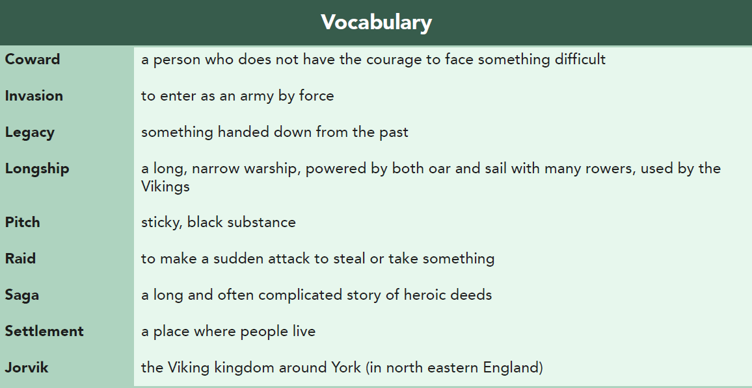
It would be ideal to ensure your child is familiar with the definitions of our topic related words – as you can see in the list titled ‘Vocabulary.’

We will be having plenty of discussions around democracy and freedom of speech. I’m sure the children will enjoy many of our voting lessons, where we decide upon laws which should or shouldn’t be agreed.

We arrange the children into four teams within the classroom. To link with this topic, each team will be named a different Viking Warrior to familiarise all of the children with key Viking historical figures.

MATHS
What we’re studying | Suggested home activities
We are going to start the new term focussing primarily upon measurement. Then we will be moving into studying fractions.  Year 3 Measurement  - measure, compare, add and subtract: lengths (m/cm/mm); mass (kg/g); volume/capacity (l/ml)  - measure the perimeter of simple 2-D shapes  - add and subtract amounts of money to give change, using both £ and p in practical contexts  - tell and write the time from an analogue clock, including using Roman numerals from I to XII, and 12-hour and 24-hour clocks  - estimate and read time with increasing accuracy to the nearest minute; record and compare time in terms of seconds, minutes and hours; use vocabulary such as o'clock, am/pm, morning, afternoon, noon and midnight  - know the number of seconds in a minute and the number of days in each month, year and leap year  - compare durations of events  Year 3 Fractions  - count up and down in tenths; recognise that tenths arise from dividing an object into 10 equal parts and in dividing one-digit numbers or quantities by 10  - recognise, find and write fractions of a discrete set of objects: unit fractions and non-unit fractions with small denominators  - recognise and use fractions as numbers: unit fractions and non-unit fractions with small denominators  - recognise and show, using diagrams, equivalent fractions with small denominators  - add and subtract fractions with the same denominator within one whole  - compare and order unit fractions, and fractions with the same denominators  - solve problems that involve all of the above.  Year 4 Measurement  - convert between different units of measure  - measure and calculate the perimeter of a rectilinear figure (including squares) in centimetres and metres  - find the area of rectilinear shapes by counting squares  - estimate, compare and calculate different measures, including money in pounds and pence  - read, write and convert time between analogue and digital 12 and 24-hour clocks  - solve problems involving converting from hours to minutes, minutes to seconds, years to months, weeks to days  Year 4 Fractions  - recognise and show, using diagrams, families of common equivalent fractions  - count up and down in hundredths; recognise that hundredths arise when dividing an object by a 100 and dividing tenths by 10.  - solve problems involving increasingly harder fractions to calculate quantities, and fractions to divide quantities, including non-unit fractions where the answer is a whole number  - add and subtract fractions with the same denominator  - recognise and write decimal equivalents of any number of tenths or hundredths  - recognise and write decimal equivalents to ¼; ½; ¾  - find the effect of dividing a one- or two-digit number by 10 and 100, identifying the value of the digits in the answer as ones, tenths and hundredths  - round decimals with 1 decimal place to the nearest whole number  - compare numbers with the same number of decimal places up to 2 decimal places  - solve simple measure and money problems involving fractions and decimals to 2 decimal places. | Below are some interactive learning activities which will help aid your child’s understanding of measurement and fractions. These activities are ones you can work through together, to check understanding whilst you answer the questions.  Measurement  https://www.topmarks.co.uk/maths-games/measuring-in-cm  https://mathsframe.co.uk/en/resources/resource/119/find_the_start_time#  https://www.scootle.edu.au/ec/viewing/L9643/index.html  Fractions  https://phet.colorado.edu/sims/html/fraction-matcher/latest/fraction-matcher_en.html  https://phet.colorado.edu/sims/html/fractions-equality/latest/fractions-equality_en.html  https://mathsframe.co.uk/en/resources/resource/120/match_fractions_decimals_and_percentages#.UCdcd2MsCEY  Measurement challenges.  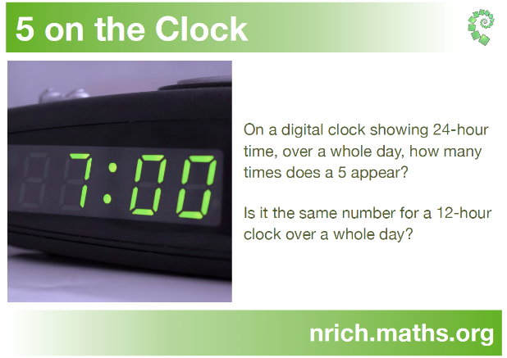  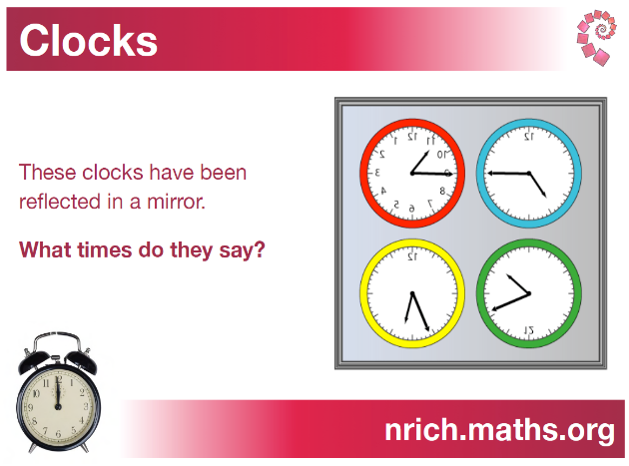  Fraction challenges.  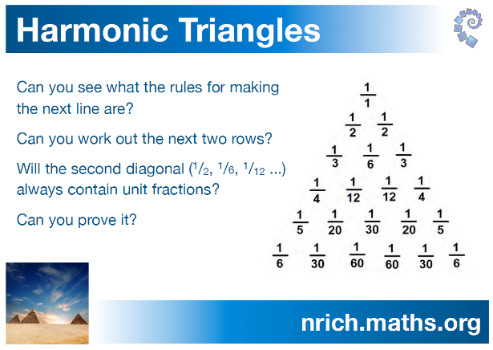  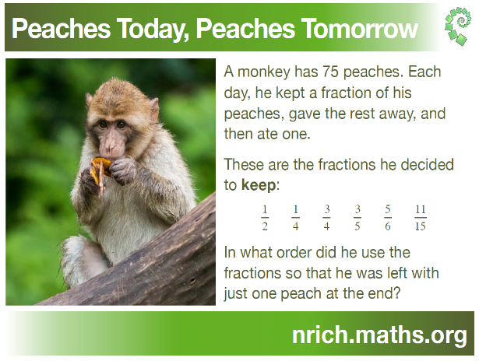
ENGLISH
What we’re studying | Suggested home activities
For this half term, the text we will be exploring is called ‘Arthur and the Golden Rope’ written by Joe Todd Stanton.  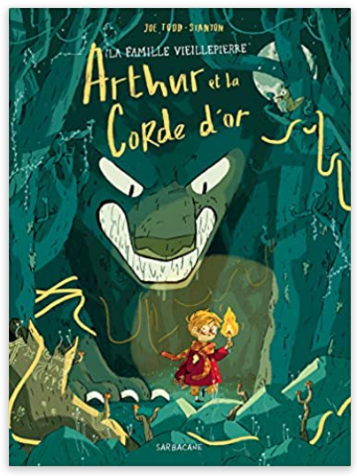  This text is a Graphic Novel, which has a History focus which is based upon Vikings and Norse Mythology. A key element to this text is perseverance and bravery.  Whilst exploring this text, the skills we will be focussed upon are…  - Reading illustration  - Lifting meaning through performance reading Predicting  - Developing inference  - Developing experience by making intertextual connections  - Looking at language  And our writing journey and outcome will be a Comic Book Narrative. | 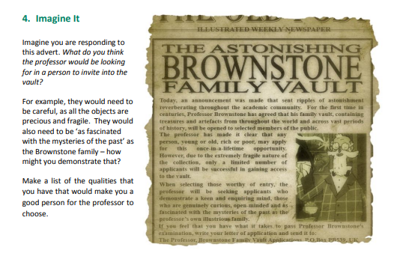  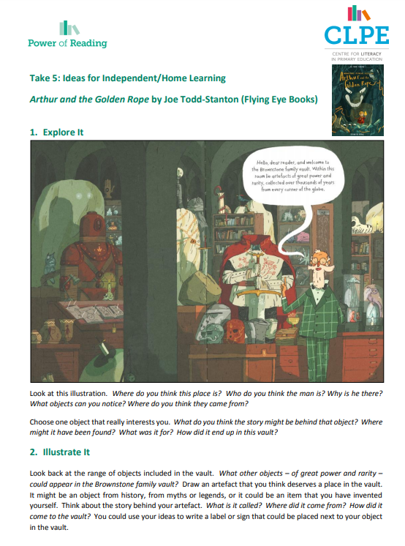
OTHER SUBJECTS
Music:
We will be using a range of different computer programmes to explore music, as well as recognising different musical patterns and identifying sounds made by differing instruments. This term the children will learn to know that music can affect mood and emotions, identify the features of major and minor tonality and to understand and explain their own personal likes and dislikes in music, related back to the elements of music.

Religious Education: Within Religious Education we will be exploring the Understanding Christianity: Salvation unit.
Throughout this unit the discussions and lessons will help to enable pupils to know about and understand Christianity as a living world faith. We will be exploring core theological concepts which enables pupils to develop knowledge and skills in making sense of Christian texts and understanding their impact in the lives of Christian people. It will also aid and develop pupils’ abilities to connect, critically reflect upon, evaluate and apply their learning to their own growing understanding of religion and belief of themselves, the world and human experience. Salvation means being saved from sin, and Christians believe that salvation is essential to have a relationship with God while on earth, and to have eternal life with God in heaven after death.

P4C: We will be carrying out P4C sessions once a week, to ensure that the children are able to explore different viewpoints and can exercise their enquiry skills. I have included an overview of what Philosophy for Children is, so that you can view the benefits.
- An enquiry based approach to open up children’s learning through the exploration of ideas.
- It gives children the possibility of seeing that their ideas have value, and that others have different ideas that have value too. They realise that they don’t always have to be right. They have the confidence to ask questions and learn through discussion. All learners (including teachers) have opportunities to genuinely enquire.
- A chance to speak and be heard without fear of getting an answer wrong. Intelligence and curiosity grows.

MFL – French

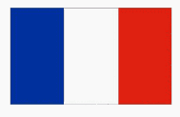
Each day after lunch we will practising counting from zero to twenty and beyond in French and also learning key phrases through a range of different songs, as well as recalling the days of the week and identifying different animals, fruit and food items in French.

HOME LEARNING ARRANGEMENTS
Home learning is set each Friday and the children have the overview of the spelling and times table activities in their home learning folders. Spellings should be practised in the little blue spelling book and the times tables are to be written out in the orange book. The children have the opportunity to win a Golden Ticket, which is 5 team points towards their team score. There are five Golden Tickets up for grabs each Friday.

It is important that the children hand their home learning in either on or before Wednesday. Every other week is topic learning and so this will also be shown on your home learning overview- linked to ‘Law and Order.’ We check the reading records each Friday (to see how many times each child has read that week) and so it’s important that each time your child reads, that they write down where they have read up to. We are encouraging independence by asking them to record this themselves. The children’s reading records should be in, each day. We have reading sessions each day after lunch. The children also have the opportunity to read online books and answer questions about understanding, throughout the week at school, as well as at home. This is through our online Oxford Reading Scheme interactive resource. Your child has their username and password in their reading records.

Each Monday we will send home an Oxford Reading book, which is matched to your child’s level of reading. They can read in class and at home, throughout the week.
PHYSICAL EDUCATION
We have physical education every Thursday and Friday afternoon. All children are to come dressed in their PE Kit on these days.

Thursday afternoon will be Tag Rugby and will be delivered by Colchester United coaches and on Friday afternoon we will be focussing on athletic skills.
COMMUNICATION
For quick, day-to-day classroom matters please contact me via Seesaw or at the beginning/end of the day. I will respond to your queries as soon as I am able to.
For queries, questions or concerns, please make an appointment to meet with me or have a phone call.
UPDATE FOR THIS HALF TERM
Miss Brooks will continue to teach in Adventurers on a Monday.

We will also have a Forest School session on Thursday the 30th of March as Nicky Nightingale would like to carry out the final session from last term, which Adventurer’s missed out on. She’s looking forward to it and I know the children will be too. I will remind you via Seesaw nearer the time.

We have our Tendring Voice Festival performances on the evenings of the 29th and 30th of March. Just a reminder that your child will need to be dropped to The Princes Theatre for 6pm on both evenings, and ticket details will be available soon! We can’t wait for you to watch all the children sing, they sound wonderful!
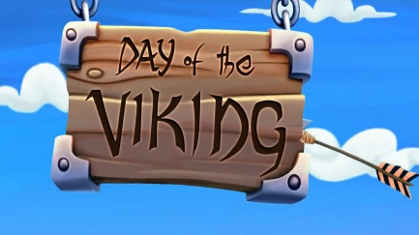
Viking Day!

On Wednesday the 1st of March we would like the children to come dressed as a famous Viking of their choice. We will have a Viking Day in class where we will learn to write how the Vikings did and understand their way of life. We will also interactively explore life in Viking times and experience what it felt like to go sailing in a longboat.

Kind regards,
Adventurers Team (Mrs Clyde Roberts, Miss Brooks, Mrs Sandell and Mrs Bishop)

