SPRING 1 CLASS LETTER

Dear Parents and Carers,

Welcome to this half-term’s class letter. This letter contains all the information you need to know about your child’s learning for the coming half term, including how you can support your child’s learning at home.
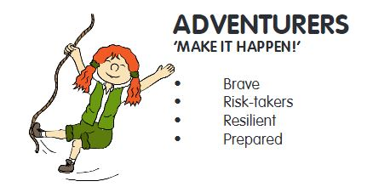

DIMENSIONS - LEARNING MEANS THE WORLD
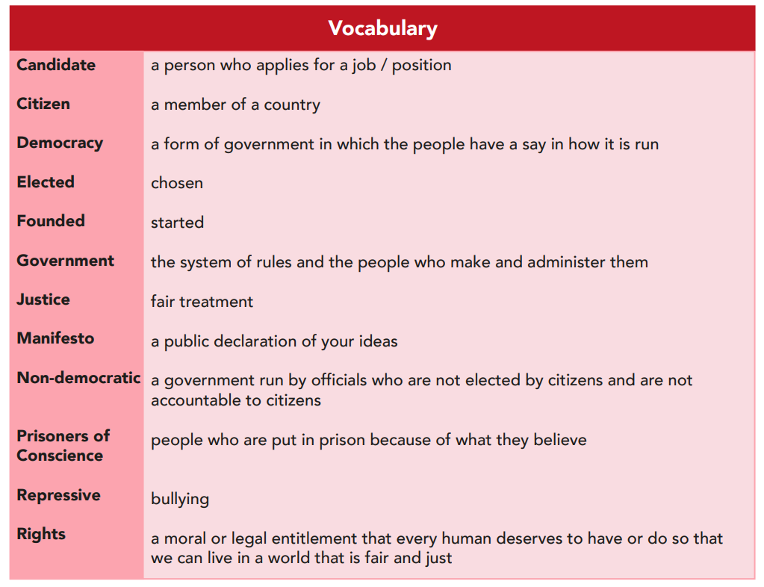
Our second topic this term is called ‘Law and Order.’ This is a thematic unit with a key focus on the history of law. "Law and Order" is a thematic unit, based on the concept of justice, with a key focus on citizenship. We will look at the importance of leadership and the meaning of democracy and its origins, before moving on to how this applies practically in communities, both school-wide, locally and nationally. We finish by recognising issues of justice, rights and responsibilities in their own setting and the wider world.

It would be great to ensure your child is familiar with the definitions of our topic related words – as you can see in the list titled ‘Vocabulary.’

We will be having plenty of discussions around democracy and freedom of speech. I’m sure the children will enjoy many of our voting lessons, where we decide upon laws which should or shouldn’t be agreed.

We arrange the children into four teams based on their tables. To link with this topic, the teams will be named …

Team 1 - Judges
Team 2 - Jury
Team 3 - Witnesses
Team 4 - Defendants

MATHS
What we’re studying | Suggested home activities
We are going to be continuing our practise of our multiplication recall skills and being able to successfully use multiplication formal methods.  We will also be working on our division understanding and using the inverse as much as possible, to highlight the clear link between multiplication and division.  Year 3…  - Recall and use multiplication and division facts for the 3, 4 and 8 multiplication tables.  - Write and calculate mathematical statements for multiplication and division using the multiplication tables that they know, including for two-digit numbers times one-digit numbers, using mental and progressing to formal written methods.  - Solve problems, including missing number problems, involving multiplication and division, including positive integer scaling problems and correspondence problems in which n objects are connected to m objects.  Year 4…  - Recall multiplication and division facts for multiplication tables up to 12 × 12.  - Use place value, known and derived facts to multiply and divide mentally, including: multiplying by 0 and 1; dividing by 1; multiplying together 3 numbers.  - Recognise and use factor pairs and commutativity in mental calculations.  - Multiply two-digit and three-digit numbers by a one-digit number using formal written layout.  - Solve problems involving multiplying and adding, including using the distributive law to multiply two digit numbers by 1 digit, integer scaling problems and harder correspondence problems such as n objects are connected to m objects. | Below are some interactive learning activities which will help aid your child’s understanding of multiplication and division. These activities are ones you can work through together, to check understanding whilst you answer the questions.  https://mathsframe.co.uk/en/resources/resource/477/Multiplication-Tables-Check  https://www.topmarks.co.uk/maths-games/hit-the-button  https://www.topmarks.co.uk/times-tables/coconut-multiples  https://www.topmarks.co.uk/number-facts/number-fact-families  https://www.topmarks.co.uk/maths-games/multiples-and-factors  https://phet.colorado.edu/en/simulations/arithmetic  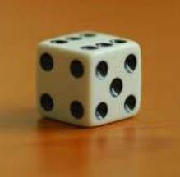  You can also play simple games together, like… Multiplication War  How to Play: Each player has two dice. Players roll at the same time and multiply their numbers. The player with the highest answer wins that round. The one with the most tally marks after ten rounds wins.  Here is the one player online version of this game…  https://matheasily.com/multiplication-dice-game.html  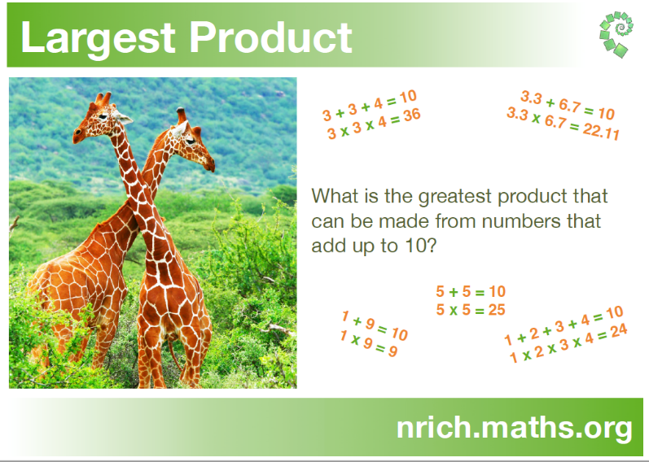  Multiplication and Division Problem Solving Challenge…
ENGLISH
What we’re studying | Suggested home activities
For this half term, the text we will be exploring is called ‘Varjak Paw’  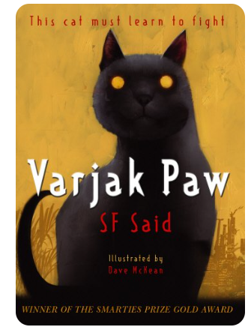  Whilst exploring this text, the skills we will be focussed upon are…  - Visualising  - Scanning and close reading Predicting  - Developing inference  - Character comparison Looking at language  - Predicting and summarising  - Making intertextual connections  And our writing journey and outcome will be a Newspaper report. | 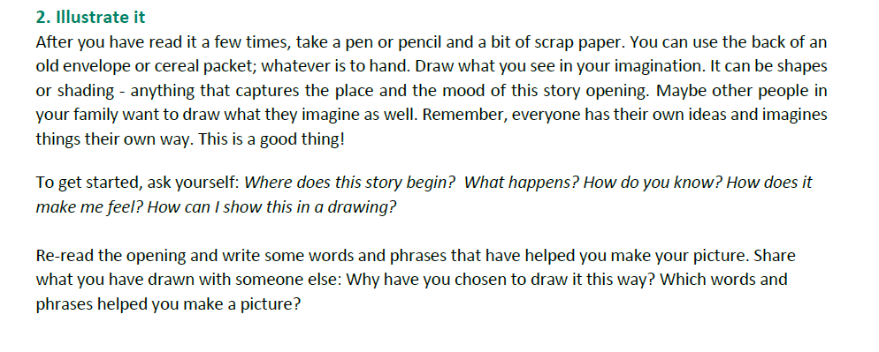  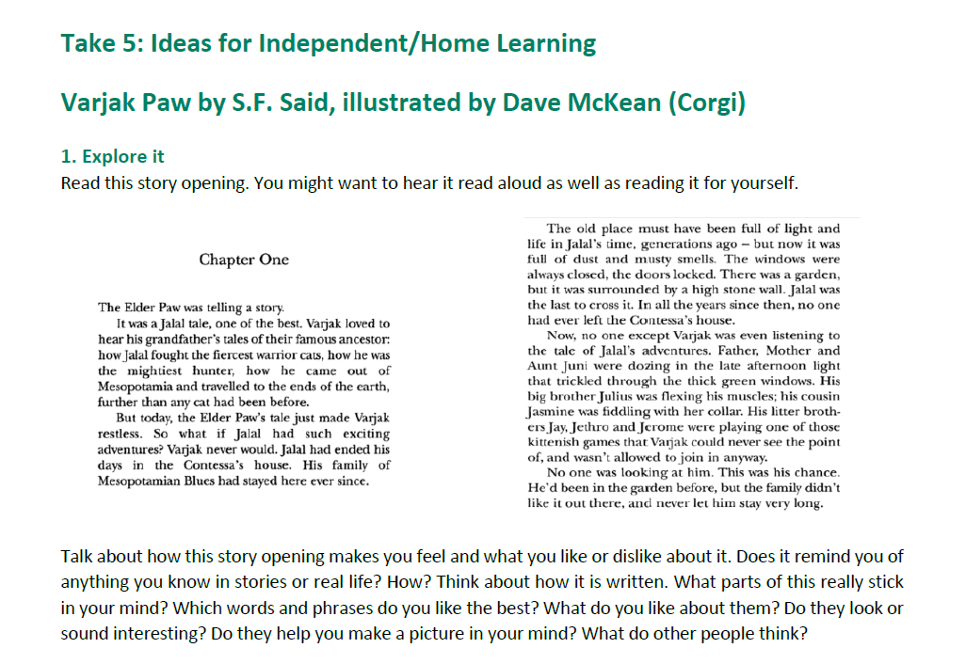
OTHER SUBJECTS
Music:
We will be using a range of different computer programmes to explore music, as well as recognising different musical patterns and identifying sounds made by differing instruments. This term the children will learn to know that music can affect mood and emotions, identify the features of major and minor tonality and to understand and explain their own personal likes and dislikes in music, related back to the elements of music.

Religious Education: Within Religious Education we will be exploring the understanding Judaism unit. Throughout this unit the discussions and lessons will help to enable pupils to know about and understand Judaism as a living world faith. We will be exploring core theological concepts which enables pupils to develop knowledge and skills in making sense of Jewish texts and understanding their impact in the lives of Jewish people. It will also aid and develop pupils’ abilities to connect, critically reflect upon, evaluate and apply their learning to their own growing understanding of religion and belief of themselves, the world and human experience.

Here are some key vocabulary and definitions which will give your child an insight into Judaism.
The Star of David - This is the symbol for Judaism. It represents the shape of King David's shield.
Menorah - A type of candlestick which holds seven candles. It is never lit and is a symbol of the Jewish people.
Kippah - A small round cap worn by Jews when they pray. Some Jews wear this all the time.
Kosher food - This is what Jews eat. They do not eat shellfish and pork. They also do not eat dairy foods at the same time as meat.
Shabbat - The seventh day of the week, a day of rest. It comes from the bible that God rested from creating the universe on the seventh day of that first week, so Jews rest from work on the Sabbath.
Mezuzah - Fixed to a doorpost inside the house, the mezuzah contains part of the hold Shema prayer. Jews touch this every time they enter or leave the house.

- P4C: We will be carrying out P4C sessions once a week, to ensure that the children are able to explore different viewpoints and can exercise their enquiry skills. I have included an overview of what Philosophy for Children is, so that you can view the benefits.
- An enquiry based approach to open up children’s learning through the exploration of ideas.
- It gives children the possibility of seeing that their ideas have value, and that others have different ideas that have value too. They realise that they don’t always have to be right. They have the confidence to ask questions and learn through discussion. All learners (including teachers) have opportunities to genuinely enquire.
- A chance to speak and be heard without fear of getting an answer wrong. Intelligence and curiosity grows.

HOME LEARNING ARRANGEMENTS
Home learning is set each Friday and the children have the overview of the spelling and times table activities in their home learning folders. Spellings should be practised in the little blue spelling book and the times tables are to be written out in the orange book. The children have the opportunity to win a Golden Ticket, which is 5 team points towards their team score. There are five Golden Tickets up for grabs each Friday.

It is important that the children hand their home learning in either on or before Wednesday. Every other week is topic learning and so this will also be shown on your home learning overview- linked to ‘Law and Order.’ We check the reading records each Friday (to see how many times each child has read that week) and so it’s important that each time your child reads, that they write down where they have read up to. We are encouraging independence by asking them to record this themselves. The children’s reading records should be in, each day. We have reading sessions each day after lunch. The children also have the opportunity to read online books and answer questions about understanding, throughout the week at school, as well as at home. This is through our online Oxford Reading Scheme interactive resource. Your child has their username and password in their reading records.

Each Monday we will send home an Oxford Reading book, which is matched to your child’s level of reading. They can read in class and at home, throughout the week.
PHYSICAL EDUCATION
We have physical education every Thursday and Friday afternoon. All children are to come dressed in their PE Kit on these days.
Thursday afternoon is currently multi-skills and will be delivered by Colchester United coaches and on Friday afternoon we will be exploring movements to music, linked to our topic. Rather than ‘Lord of the Dance’ we will be choreographing a piece called ‘Law of the Dance.’
COMMUNICATION
For quick, day-to-day classroom matters please contact me via Seesaw or at the beginning/end of the day. I will respond to your queries as soon as I am able to.
For queries, questions or concerns, please make an appointment to meet with me or have a phone call.
UPDATE FOR THIS HALF TERM
Miss Brooks will continue to teach in Adventurers on a Monday. Mrs Mocano will also be joining us this half term. She is a Trainee Teacher and will be teaching the children most Tuesdays and Fridays. I will be mentoring Mrs Mocano, so will be in class on these days also. Mrs Mocano has visited our class, before we broke up for Christmas, so the children are familiar with her.
Kind regards,
Adventurers Team (Mrs Clyde Roberts, Miss Brooks, Mrs Sandell and Mrs Bishop)

