AUTUMN 2 CLASS LETTER

Dear Parents and Carers,

Welcome to this half-term’s class letter. This letter contains all the information you need to know about your child’s learning for the coming half term, including how you can support your child’s learning at home.
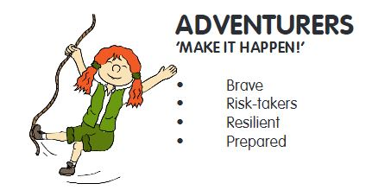

DIMENSIONS LEARNING MEANS THE WORLD
Our second topic this term is called ‘Out and About.’ This is a thematic unit with a key focus on
geography. We will be naming and locating counties and cities of the United Kingdom, geographical regions and their identifying human and physical characteristics, using the eight points of a compass,
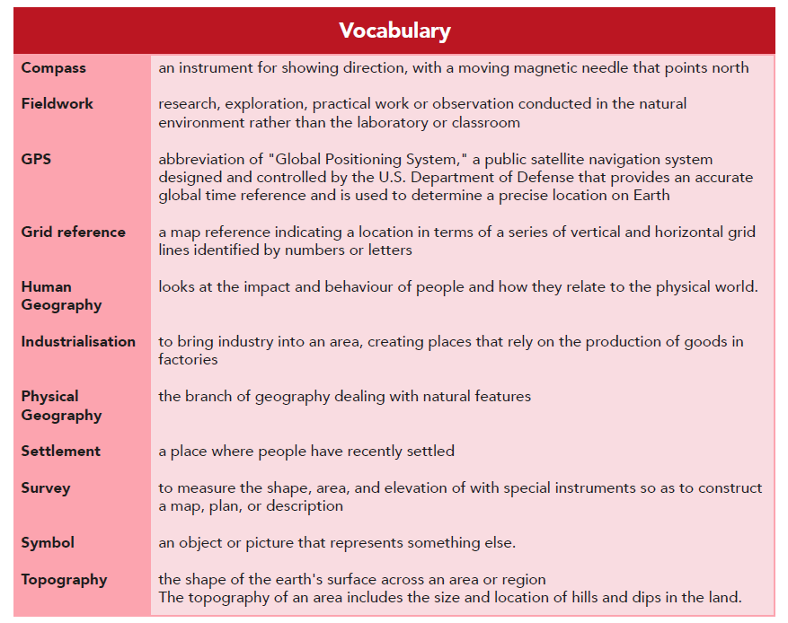
four-figure grid references, symbols and keys; using fieldwork to observe, measure and record the human and physical features in the local area and developing and understanding of where the place our school is located is like it is.
It would be great to ensure your child is familiar with the definitions of our topic related words – as you can see in the list titled ‘Vocabulary.’

I am in the process of organising a trip to Dedham, Flatford Mill for late November / early December. This will be a field study trip, with a focus on geographical physical features. This will go ahead if we can find a coach for a reasonable price. Letters will be out in due course. If you are able to volunteer on this trip, once we know dates, please do to let me know.
MATHS
What we’re studying | Suggested home activities
We are going to be continuing the term by focussing on place value, as this is the core of each Maths process and feeds into all the other elements of Maths learning. This term we will be investigating the following objectives, using a range of different learning strategies.  We will also be practising our times tables/ division facts to ensure this knowledge builds alongside the place value.  Year 3…  Count from 0 in multiples of 4, 8, 50 and 100  Find 10 or 100 more or less than a given number  Recognise the place value of each digit in a three-digit number (hundreds, tens, ones)  Compare and order numbers up to 1000 Identify, represent and estimate numbers using different representations  Read and write numbers up to 1000 in numerals and in words  Year 4…  Count in multiples of 6, 7, 9, 25 and 1000 Find 1000 more or less than a given number.  Count backwards through zero to include negative numbers.  Recognise the place value of each digit in a four-digit number (thousands, hundreds, tens, and ones).  Order and compare numbers beyond 1000.  Identify, represent and estimate numbers using different representations.  Round any number to the nearest 10, 100 or 1000.  Solve number and practical problems that involve all of the above and with increasingly large positive numbers.  Read Roman numerals to 100 (I to C) and know that over time, the numeral system changed to include the concept of zero and place value. | Below are some interactive learning activities which will help aid your child’s understanding of place value. These activities are ones you can work through together, to check understanding whilst you answer the questions.  https://www.topmarks.co.uk/learning-to-count/place-value-basketball  https://www.topmarks.co.uk/place-value/bead-numbers  https://www.topmarks.co.uk/carroll-diagrams/odd-and-even  https://www.topmarks.co.uk/place-value/place-value-charts  https://www.topmarks.co.uk/maths-games/daily10  https://mathsframe.co.uk/en/resources/resource/59/itp-beadsticks  https://ictgames.com/sharkNumbers/mobile/index.html  https://mathsframe.co.uk/en/resources/resource/569/Parachute-Number-Line  https://mathsframe.co.uk/en/resources/resource/589/Rounding-Shoot-Out  https://mathsframe.co.uk/en/resources/resource/574/Comparing-Numbers-using-Dienes  https://mathsframe.co.uk/en/resources/resource/37/placing-numbers-on-a-number-line  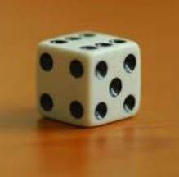  You can also play simple games like asking your child to roll a dice four times and the child creating the largest three or four-digit number they can, using the four numbers they have.  Or create four (or more) different numbers using the numbers they have rolled. So for example your child rolls a 2, 5, 6 and a 1.  6251  2561  6125  5216  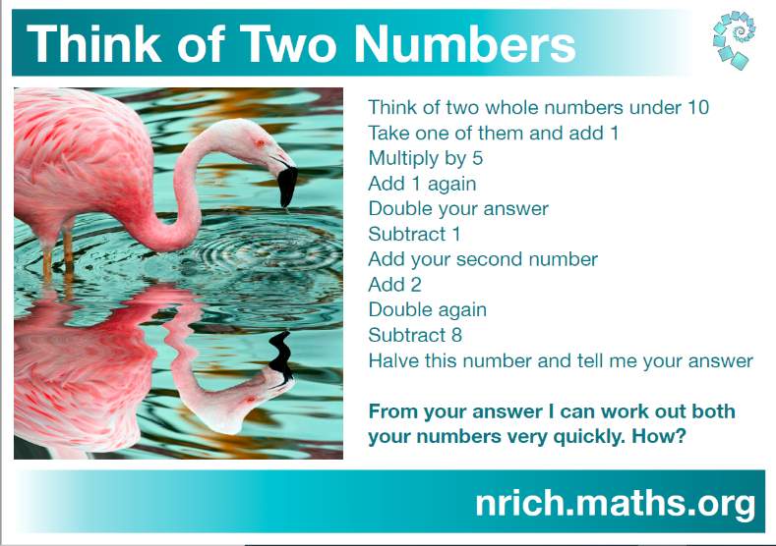  Place Value Problem Solving Challenge
ENGLISH
What we’re studying | Suggested home activities
For this half term, the text we will be exploring is called ‘The Wild Robot.’    Whilst exploring this text, the skills we will be focussed upon are…  - Visualising  - Reading illustration Scanning and close reading  - Character comparison  - Looking at language Predicting and summarising  - Performance reading  - Developing inference  - Making personal connections  And our writing journey and outcome will be a story sequel.  November Book Week  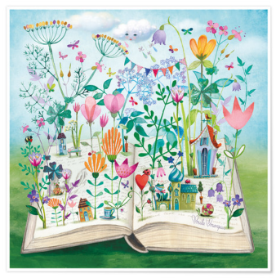 | 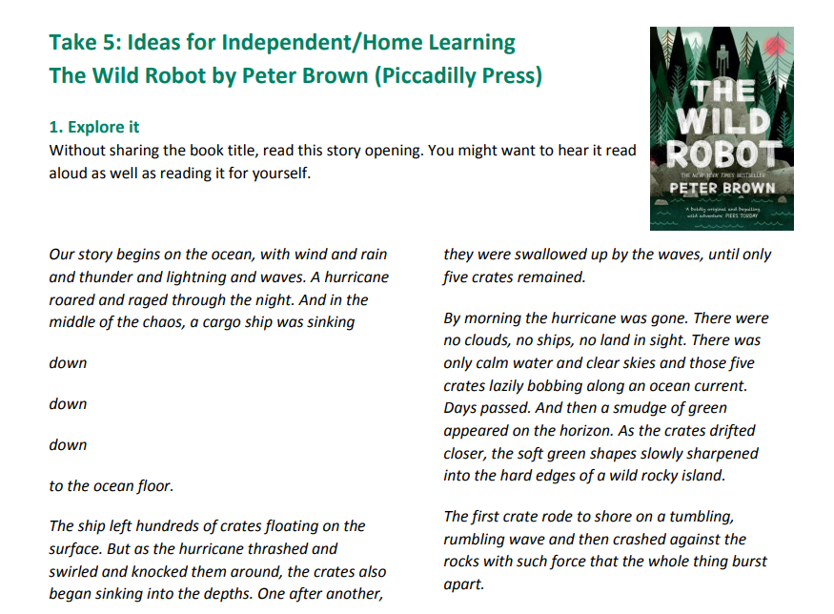  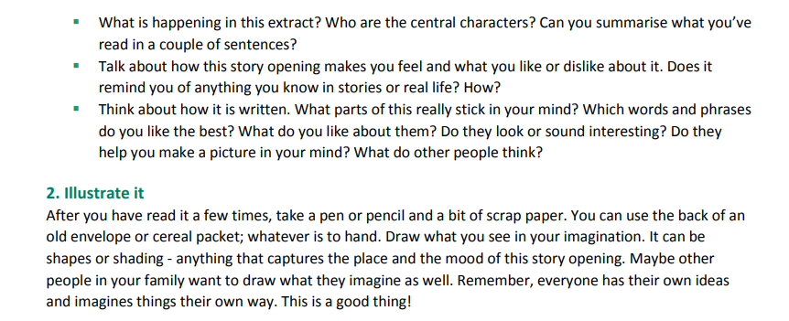  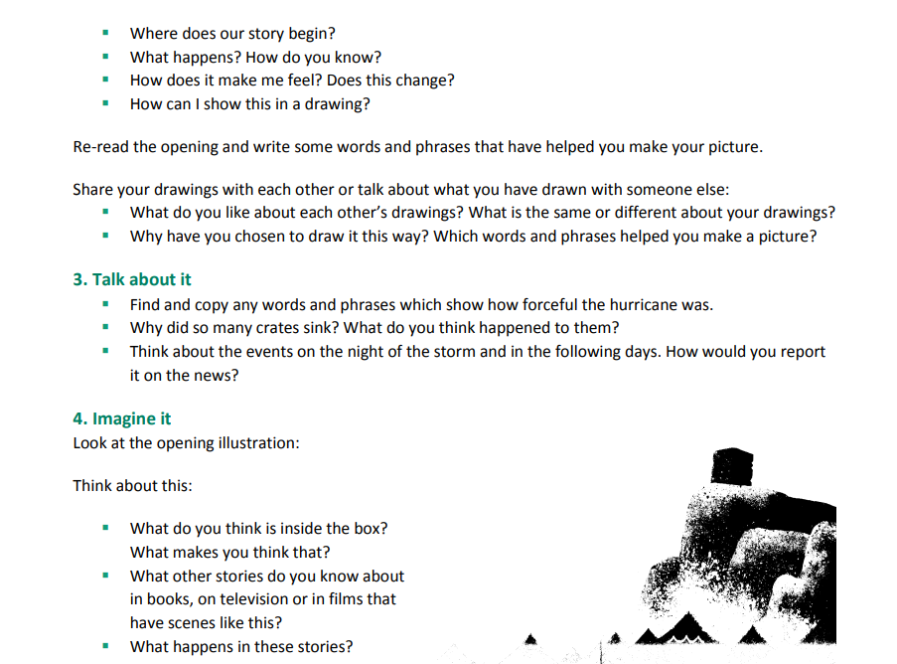  During the week beginning the 14th of November we will be studying a book for the whole week and have some surprises in store for the children. I won’t mention the name of the chosen book as we don’t want the children knowing in advance.
OTHER SUBJECTS
Music:
We will be using a range of different computer programmes to explore music, as well as recognising different musical patterns and identifying sounds made by differing instruments. This term the children will learn to know that music can affect mood and emotions, identify the features of major and minor tonality and to understand and explain their own personal likes and dislikes in music, related back to the elements of music.

Religious Education: Within Religious Education we will be exploring the understanding Christianity unit. Throughout this unit the discussions and lessons will help to enable pupils to know about and understand Christianity as a living world faith. We will be exploring core theological concepts which enables pupils to develop knowledge and skills in making sense of biblical texts and understanding their impact in the lives of Christians. It will also aid and develop pupils’ abilities to connect, critically reflect upon, evaluate and apply their learning to their own growing understanding of religion and belief (particularly Christianity), of themselves, the world and human experience.

- P4C: We will be carrying out P4C sessions once a week, to ensure that the children are able to explore different viewpoints and can exercise their enquiry skills. I have included an overview of what Philosophy for Children is, so that you can view the benefits.

- An enquiry based approach to open up children’s learning through the exploration of ideas.
- Gives children the possibility of seeing that their ideas have value, and that others have different ideas that have value too.
- They realise that they don’t always have to be right.
- They have the confidence to ask questions and learn through discussion.
- All learners (including teachers) have opportunities to genuinely enquire.
- A chance to speak and be heard without fear of getting an answer wrong.
- Intelligence grows.
- Gives children who are not considered “academic” a voice and a chance to flourish.
- Gives the “academic” children a chance to think outside the box and to see that the non-academic have inspiring ideas.
- Gives all children value.
HOME LEARNING ARRANGEMENTS
Home learning is set each Friday and the children have the overview of the spelling and times table activities in their home learning folders. Spellings should be practised in the little blue spelling book and the times tables are to be written out in the orange book.

It is important that the children hand their home learning in either on or before Wednesday. Every other week is topic learning and so this will also be shown on your home learning overview- linked to ‘Lightning Speed.’ We check the reading records each Friday (to see how many times each child has read that week) and so it’s important that each time your child reads, that they write down where they have read up to. We are encouraging independence by asking them to record this themselves. Their reading records should be in, each day. We have reading sessions each day after lunch.

PE/FOREST SCHOOL
Monday morning will be Forest School sessions. Please can all children come dressed in their Forest School kit and remember to bring warm clothing, rain coats and wellies. They will just need a spare pair of dry trousers / leggings to change into afterwards.

We have physical education every Thursday and Friday afternoon. Thursday afternoon is currently multi-skills and will be delivered by Colchester United coaches and on Friday afternoon will be exploring movements to music.

COMMUNICATION
For quick, day-to-day classroom matters please contact me via Seesaw or at the beginning/end of the day.

For queries, questions or concerns, please make an appointment to meet with me or have a phone call.

I will respond to your queries as soon as I am able to.

Kind regards,
Adventurers Team (Mrs Clyde Roberts and Mrs Sandell)

